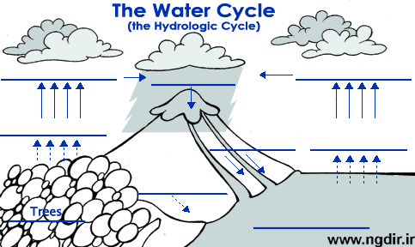

WATER CYCLE BRACELET
Components Bead Color

1. The SUN comes out. Yellow

2. Water in the OCEANS is heated and EVAPORATES. Dark Blue

3. The water vapor condenses and forms CLOUDS. White

4. The condensed droplets fall as RAIN, sleet, hail or snow. Pink

5. The rain (precipitation) falls to the GROUND. Black/ Purple

6. Water in the LEAVES on plants transpires. Green

7. Water hits the ground and creates RUN-OFF. Red

8. Water in CREEKS and STREAMS moves downhill. Light Blue

9. Water flows into larger RIVERS. Medium Blue

10. Rivers flow back into OCEANS. Dark Blue

WATER CYCLE BRACELET
Components Bead Color

1. The SUN comes out. Yellow

2. Water in the OCEANS is heated and EVAPORATES. Dark Blue

3. The water vapor condenses and forms CLOUDS. White

4. The condensed droplets fall as RAIN, sleet, hail or snow. Pink

5. The rain (precipitation) falls to the GROUND. Black/ Purple

6. Water in the LEAVES on plants transpires. Green

7. Water hits the ground and creates RUN-OFF. Red

8. Water in CREEKS and STREAMS moves downhill. Light Blue

9. Water flows into larger RIVERS. Medium Blue

10. Rivers flow back into OCEANS. Dark Blue

