Volvox Information
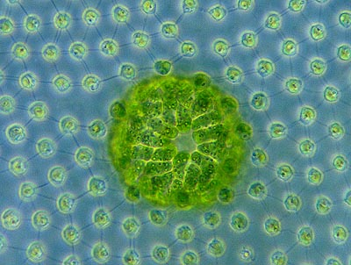
Volvox is a Chlorophyte, or green alga. It exists as a grand spherical colony. Each little alga within the colony bears two flagella, whip-like hairs. The individual alga are connected to each other by thin strands of cytoplasm that enable the whole colony to swim in a coordinated fashion. The individual alga also have small red eye spots.
The colonies even have what we could call a front and rear end. Or, since Volvox resembles a little planet, a 'north and south pole'. In the northern region the eyespots are more developed. This helps the colony to swim towards the light. This differentiation of cells make Volvoxquite unique. It is a colony that comes really close to being a multi-celled organism.
Watching groups of colonies under the light microscope is a breathtaking sight. If you leave enough space under the cover slip (with the aid of spots of Vaseline under the corners) the spheres will swim slowly towards the light of the microscope, (use dark field illumination!).
Volvox can be found relatively easy. They need quite clean nutrient rich water (Eutrophic) and it has to be warm so summer is the time of the year for a goodVolvox catch. The best thing to do is to use a plankton net but if you are lucky you can also find them by squeezing pond scum. In a jar of pond water they will swim towards the light so they are often easy to find near the surface.
The two common species in my country are Volvox aureus and Volvox globator.Volvox aureus is usually smaller and has less individual cells. Volvox globator may reach a size of 2 millimeters so they can be easily seen with the naked eye. If you are short sighted the larger Volvox aureus colonies can also be visible with a size of half a millimeter as small green dots.
Although the colony is bigger, the individual cells of Volvox globator are slightly smaller (4 micron) than the cells of Volvox aureus (5 to 8 micron). The cells ofVolvox aureus are also a bit more egg-shaped. An easier way to determine the species is to look at the sexual reproduction of Volvox.

Information obtained from: http://www.microscopy-uk.org.uk/mag/indexmag.html?http://www.microscopy-uk.org.uk/mag/artdec03/volvox.html

