LENGTH (meter)
Kilometer | km | 1000 m
Hectometer | hm | 100 m
Dekameter | dkm | 10 m
METER | m | 1 m
Decimeter | dm | 0.1 m
Centimeter | cm | 0.01m
Millimeter | mm | 0.001m
Micrometer | m
Nanometer | nm

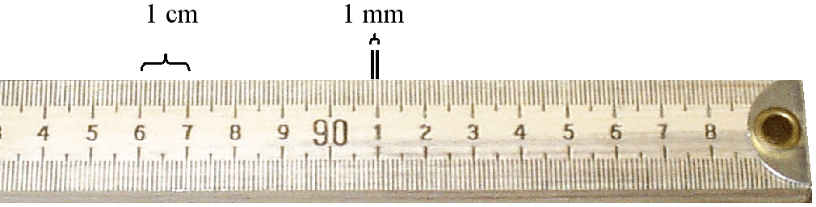
Meter stick
VOLUME (liter)
Kiloliter | kL | 1000 L  LIQUID- graduated cylinder (mL)  REGULAR SOLID- L x W x H (cm³)  IRREGULAR SOLID- displacement  final volume- initial volume = volume of object (mL)
Hectoliter | hL | 100 L
Dekaliter | dkL | 10 L
LITER | L | 1 L
Deciliter | dL | 0.1 L
Centiliter | cL | 0.01L
Milliliter | mL | 0.001L
Microliter | L
Nanoliter | nL

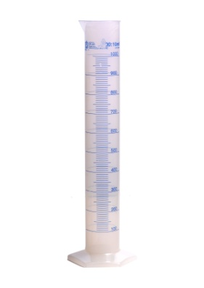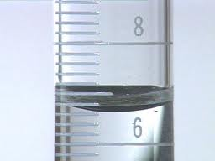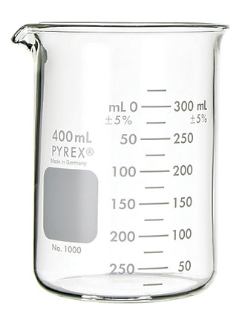
meniscus

MASS (gram)
Kilogram | kg | 1000 g
Hectogram | hg | 100 g
Dekagram | dkg | 10 g
GRAM | g | 1 g
Decigram | dg | 0.1 g
Centigram | cg | 0.01g
Milligram | mg | 0.001g
Microgram | g
Nanogram | ng

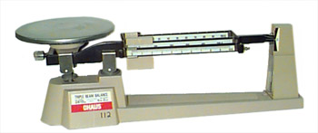
Triple Beam Balance

AREA (m² or cm²)
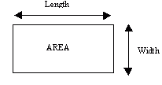

TEMPERATURE (Cº or Kº)
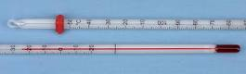 Thermometer

TIME (seconds)
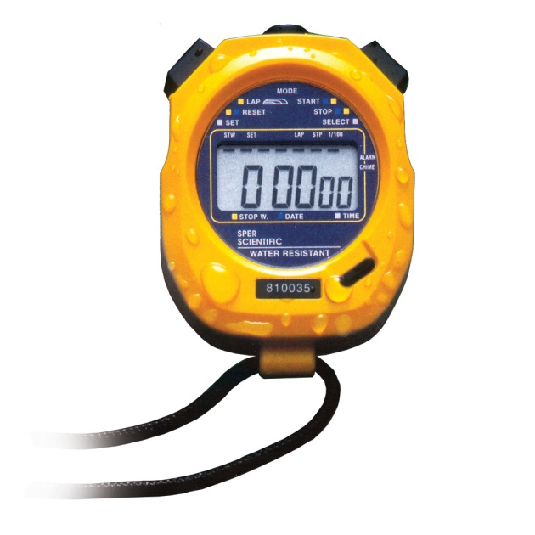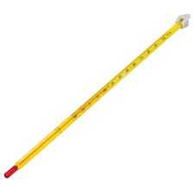
Stopwatch

