Painting Analysis
Directions: Use the painting to respond to the questions below. Write your answers in complete sentences.
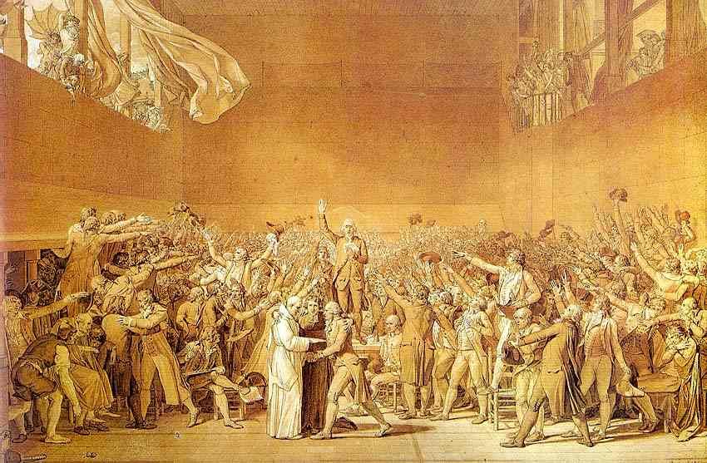
- What do you think the painter was trying to communicate in this painting?

- Who is present during the taking of the oath? Who is missing?

- What is the “Tennis Court Oath”?

- What different emotions are represented in the facial expressions and body language of those present?

- Do you think the painter was present during the taking of the oath? Why or why not?

Painting Analysis
Directions: Use the painting to respond to the questions below. Write your answers in complete sentences.
- What do you think the painter was trying to communicate in this painting?

- Who is present during the taking of the oath? Who is missing?

- What is the “Tennis Court Oath”?

- What different emotions are represented in the facial expressions and body language of those present?

- Do you think the painter was present during the taking of the oath? Why or why not?

