NAME ________________________________ BLOCK __________ DATE _________________
STUDY GUIDE: French Revolution

Diagram Skills
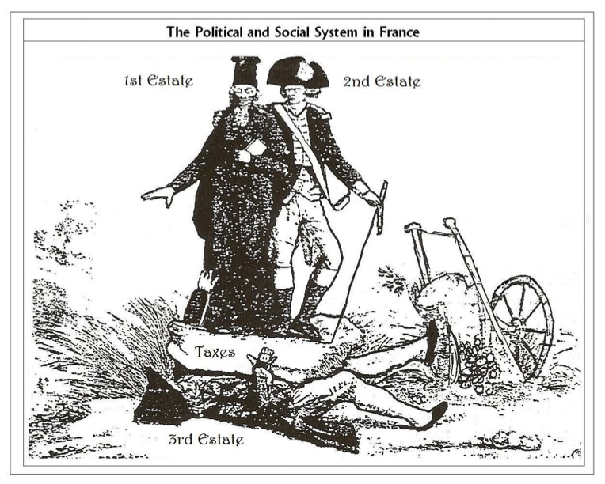

- The man with the two people and rock on top of him is from which estate?
- First b. Second c. Third d. Fourth

- The man with the sword is from which estate?
- First b. Second c. Third d. Fourth

- The man in the black robe is from which estate?
- First b. Second c. Third d. Fourth

- What does the rock symbolize in this picture?
- Taxes b. Food shortage c. No rights d. No religious freedom

Multiple Choice

- Choose the correct chronological order:
1. Convening the Estates General
2. The Declaration of the Rights of Man and the Citizen.
3. Formation of the National Assembly.
4. The Tennis Court Oath.
a. 1, 2, 3, 4 b. 3, 2, 1, 4 c. 2, 4, 1, 3. d. 1, 3, 4, 2

- Why did Louis XVI finally agree to summon the Estates General?
a. He feared invasion from England c. The Estates General forced him to
b. France was bankrupt and nobles requested it d. The Sans Culottes were demanding reform

- What contributed to France’s financial crisis?
a. a drop in gold supply c. peasant uprisings
b. an extended period of peace d. bad harvests, famine, and increase in bread prices

- The bourgeoisie belong to which of the following groups?
- First Estate b. Second Estate c. Third Estate d. Fourth Estate

- The poorest members of the Third Estate were
a. urban workers. b. bourgeois families c. nuns and priests. d. doctors.

- In France’s old order, which of the following groups were members of the bourgeoisie?
a. nobles b. clergy c. peasants d. doctors

- In 1789, claiming that they represented the people, delegates of the Third Estate formed the _____.
a. National Assembly b. Committee of Public Safety c. Legislative Assembly d. Directory

- What form of government existed when the National Assembly was formed in 1789?
a. republic b. limited monarchy c. absolute monarchy d. democracy

- Participants in the Tennis Court Oath swore to continue meeting until they were able to bring about
a. a reduction in taxes. c. a new constitution.
b. the overthrow of Louis XVI. d. the fall of the Bastille.

- Why did the people of Paris Storm the Bastille?
- to kill the guards c. to free the prisoners
- to get to the weapons and gunpowder d. to kill the king

- The Declaration of the Rights of Man and Citizens stated that
- All men are born free and equal c. All male citizens had the right to vote
- Male citizen and female citizens were equal before the law d. All citizens had to pay taxes

- What form of government did the National Assembly create with the Constitution of 1791?
a. an absolute monarchy b. a republic c. a theocracy d. a limited monarchy

- Which was set up as part of the new limited monarchy of France?
a. National Assembly b. Committee of Public Safety c. Legislative Assembly d. Directory

- Why were European rulers against the French Revolution?
- It promoted the French monarchy c. It took away the power of the church
- They were afraid it would spread d. It took too long

- In the Declaration of Pillnitz, the king of Prussia and emperor of Austria
a. declared war on the French revolutionaries. c. threatened military action to protect French monarchy.
b. declared their support for the French Revolution. d. offered to take in the exiled French royal family.

- The women of Paris marched on Versailles for
a. control of government b. weapons c. bread d. shelter

- Working class men and women who desired radical change.
- Bourgeoisie b. Girondins c. Jacobins d. Sans-culottes

- A radical political club made up of middle class lawyers and intellectuals.
- Bourgeoisie b. Girondins c. Jacobins d. Sans-culottes

- A moderate political club made up of middle class lawyers and intellectuals.
- Bourgeoisie b. Girondins c. Jacobins d. Sans-culottes

- In 1792, the National Convention voted to abolish monarchy and declare France __________.
a. dissolved b. bankrupt c. a republic d. a nation

- In 1793 King Louis XVI and Marie Antoinette were
a. returned to the throne c. saved from the mob by Lafayette
b. deported from England d. executed

- The leader of the Reign of Terror was________.
a. Marie Antoinette b. Robespierre c. Olympe de Gouges d. Dr. Joseph Guillotine

- What machine killed thousands during the Reign of Terror?
- Machine gun b. Cannon c. Guillotine d. Axe

- During Reign of Terror (1793-1794), Robespierre tried to
- Execute all French nobles. c. Crush all opposition to the revolution.
- Restore the Catholic Church. d. Reinstate the king and queen.

- During the Reign of Terror, trials and executions were carried out under the authority of
a. Louis XVI. b. the National Assembly. c. the Committee of Public Safety. d. Napoleon.

- The Constitution of 1795 set up a five man _____ and a two house legislature.
a. National Assembly b. Committee of Public Safety c. Legislative Assembly d. Directory

- The Directory that ruled from 1795 to 1799 was _________.
a. popular with sans-culottes b. a failure c. skillfully managed d. abolished after only a year

- Napoleon was able to take over power from the
- King and Queen b. Directory c. Robespierre d. Church

