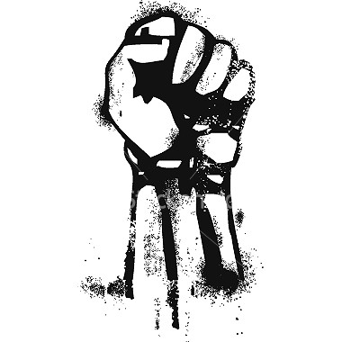 | CAUSES OF REVOLUTIONS  - _________ ____________ – taxation, drought, famine, economic downturns  - _________ _______ – wars of independence  - _________ _______ – French soldiers who had fought on the American side in the War of Independence (1775-1783) often returned to France with new ideas of liberty
WHAT IS A REVOLUTION?
A dramatic and wide-reaching _________ in the way something works or is organized or in people’s ideas about it (usually non-violent) | A forcible __________ of a government or social order in favor of a new system (usually __________).

CHARACTERISTICS OF REVOLUTIONS
- ___________ is a common feature – usually the execution of rulers.
- Preceded by a strong ________. There must be a central idea for change before a revolution can occur.
- Happens in ________ or _________.
- Replaces an old order with a _______ ______________.
- Ruler refused to ___________.

