**CAUSES**

**CAUSES**

**CAUSES**

Effects

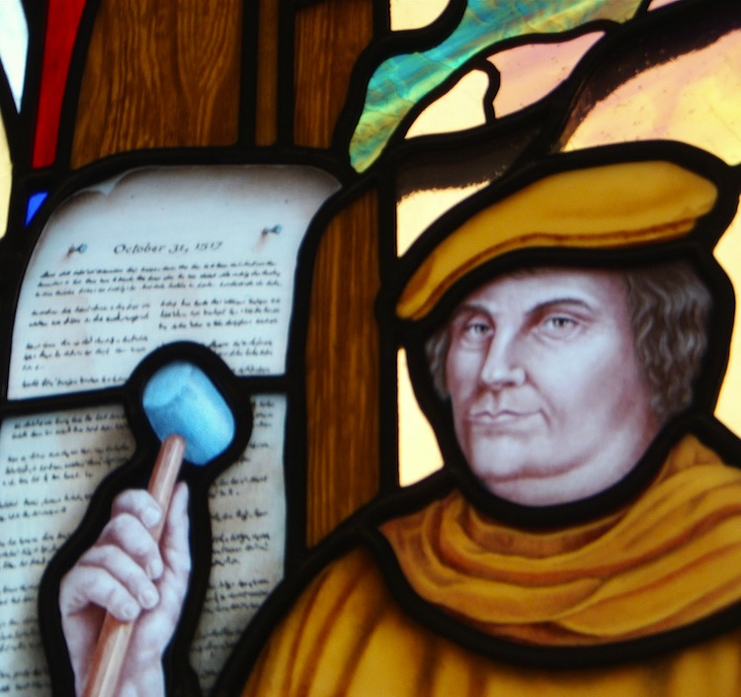

**Martin**

**Luther’s**

**Actions**

**Opened people’s eyes to the ___________ of the church.**

**Soon others began to create new _____________ away from the Roman Catholic Church based on own beliefs – John Calvin - Calvinism**

**_____________**

Focus on the Individual

**____________**

Rise of Wealth and the Middle Class

**_____________**

Focus on the Individual

**____________**

Rise of Wealth and the Middle Class

**____________**

Questioned their faith

**People began to question their lives and church authority.**

**New Christian ______________(religions) emerged. Protestant, Lutheran, Baptists, Puritans, Methodists, Calvinists, etc.**

**_________ Power grew as Church’s power lessoned**



**Calvin’s Beliefs**

* “Faith Alone” saves you
* The Bible holds the ________
* Religious Education
* _________________ – God has already decided who is saved condemned.

**John Calvin**

* French lawyer – moved to religious community in Geneva Switzerland.

Henry VIII of England

*In America, we call this the __________ _____.

Pope _______ to grant it

Henry declares himself head of the Church of England in the “Act of ___________” 1534

Wished to ___________ Catherine of Aragon and marry Anne Boleyn

Calvinism

* Spreads to France, Germany, Netherlands, Scandinavia, Scotland
* Dutch Reformed
* Scottish Presbyterians, American Baptists, Puritans, from this branch

John Calvin