The Euglena Information
Euglena are unicellular organisms classified into the Kingdom Protista, and the Phylum Euglenophyta. All euglena have chloroplasts and can make their own food by photosynthesis. They are not completely autotrophic though, euglena can also absorb food from their environment; euglena usually live in quiet ponds or puddles.
Euglena move by a flagellum (plural ‚ flagella), which is a long whip-like structure that acts like a little motor. The flagellum is located on the anterior (front) end, and twirls in such a way as to pull the cell through the water. It is attached at an inward pocket called the reservoir. Color the reservoir grey and the flagellum black.
The Euglena is unique in that it is both heterotrophic (must consume food) and autotrophic (can make its own food). Chloroplasts within the euglena trap sunlight that is used for photosynthesis, and can be seen as several rod like structures throughout the cell. Color the chloroplasts green. Euglena also have an eyespot at the anterior end that detects light, it can be seen near the reservoir. This helps the euglena find bright areas to gather sunlight to make their food. Color the eyespot red. Euglena can also gain nutrients by absorbing them across their cell membrane, hence they become heterotrophic when light is not available, and they cannot photosynthesize.
The euglena has a stiff pellicle outside the cell membrane that helps it keep its shape, though the pellicle is somewhat flexible and some euglena can be observed scrunching up and moving in an inchworm type fashion. Color the pellicle blue.
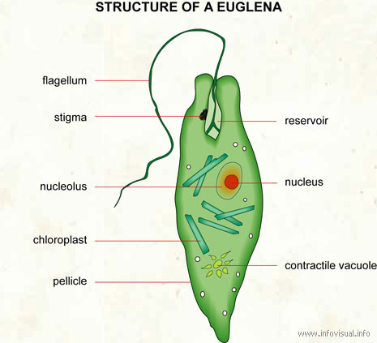
In the center of the cell is the nucleus, which contains the cell's DNA and controls the cell's activities. The nucleolus can be seen within the nucleus. Color the nucleus purple, and the nucleolus pink.
The interior of the cell contains a jelly-like fluid substance called cytoplasm. Color the cytoplasm light yellow. Toward the posterior of the cell is a star-like structure: the contractile vacuole. This organelle helps the cell remove excess water, and without it the euglena could take in some much water due to osmosis that the cell would explode. Color the contractile vacuole orange.
Structure of a euglena: flagellate freshwater protozoan. It is composed of chlorophyll and has a rudimentary eye.
Reservoir: part of a euglena used for storage.
Nucleus: central organelle of a euglena.
Contractile vacuole: cavity of the euglena that is able to contract.
Pellicle: membrane that envelops a euglena.
Chloroplast: organelle of the euglena responsible for photosynthesis.
Nucleolus: spherical body that contains the nucleus of a euglena.
Stigma: light-sensitive part of a euglena.
Flagellum: long, mobile filament used by the euglena for locomotion.

