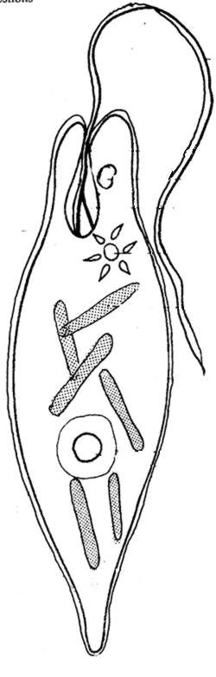
lName ____________________________

Color the Euglena according to the directions. Organelles can be identified based on their descriptions and locations Answer the following questions
1. Are euglena unicellular or multicellular?

2. What is the function of the flagellum?

3. What organelle carries out photosynthesis?

4. On which end is the flagellum located?

5. Define autotrophic.

6. Define heterotrophic.

7. Describe the two ways in which the euglena get their nutrients.

8. What is the eyespot used for?

9. What is the function of the nucleus?

10. What is the function of the contractile vacuole? What would happen if the cell did not have this organelle.

