Name: _____________________________ Block: ___________________ Date:____________
Amoeba
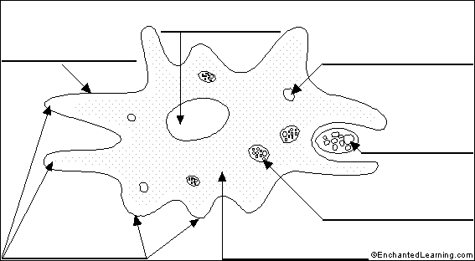

Label the Diagram
Word Bank:
Cell Membrane Nucleus Pseudopods Contractive Vacuole Cytoplasm
Food being engulfed by pseudopods Pseudopod Food Vacuole

Questions:
1. When an amoeba eats, it forms a food ____________________________.
2. An amoeba forms a __________________________ vacuole to excrete waste.
3. An amoeba consists of how many cells? __________________________
4. How big are the biggest amoebas? __________________________
5. Do any amoebas live inside animals? __________________________

