Current Events
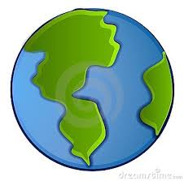
What is a current event?
Put an X next to the items
that you think are examples
of current events.

_____ | CNN Student News | _____ | This month’s TIME Magazine
_____ | Magazine article about WWII | _____ | Encyclopedia article
_____ | Map of North Carolina | _____ | Facebook post
_____ | World News Tonight | _____ | Newspaper article on a political campaign

Current Events
What is a current event?
Put an X next to the items
that you think are examples
of current events.

_____ | CNN Student News | _____ | This month’s TIME Magazine
_____ | Magazine article about WWII | _____ | Encyclopedia article
_____ | Map of North Carolina | _____ | Facebook post
_____ | World News Tonight | _____ | Newspaper article on a political campaign

Current Events
What is a current event?
Put an X next to the items
that you think are examples
of current events.

_____ | CNN Student News | _____ | This month’s TIME Magazine
_____ | Magazine article about WWII | _____ | Encyclopedia article
_____ | Map of North Carolina | _____ | Facebook post
_____ | World News Tonight | _____ | Newspaper article on a political campaign

Current Events
What is a current event?
Put an X next to the items
that you think are examples
of current events.

_____ | CNN Student News | _____ | This month’s TIME Magazine
_____ | Magazine article about WWII | _____ | Encyclopedia article
_____ | Map of North Carolina | _____ | Facebook post
_____ | World News Tonight | _____ | Newspaper article on a political campaign

