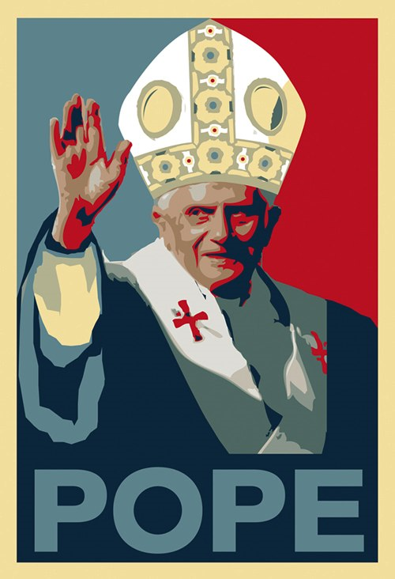

What is the Protestant Reformation?

To **________** and **_________** the **__________ ___________ __________**

The biggest authority figure of the Middle Ages was the **_________.**

**_____________**

Focus on the Individual

**____________**

Rise of Wealth and the Middle Class

**____________**

Questioned their faith

**CAUSES**

**People began to question their lives and church authority.**

**Martin Luther – 1517**

* German monk
* Questioned ________ _________
* Wrote the ____________ (95 things church is doing wrong)

**How did this become a big deal?**

* Effect of the __________ _______ – ideas are spread faster
* Opened people’s eyes to church _________________ (wrong doings)

**Church’s Reaction to Martin Luther**

* Punish him
* They want Martin Luther to _________(take back) what he said at *Diet of Worms*
  + Diet – group/assembly
  + Worms is a place in Germany
* He is ________________ (banned) from the church and forced into hiding for the rest of his life.

**Martin Luther’s Beliefs**

* “Faith Alone” will save you
* All should read the Bible in their own ___________ (language)
* __________ do not have special powers
* __________ the sacraments to baptism and communion
* Religious ____________ for all

Martin Luther & the Reformation

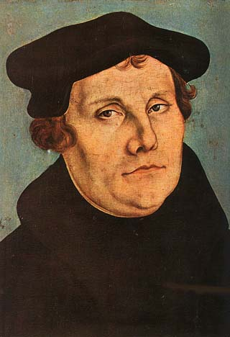

Martin Luther & the Reformation