Name: _________________________________________ Block: _________ Date: _______________

Work and Machines Test Review

Directions: Complete the following questions.

- A doorknob is an example of a _______________________________. It changes the __________________ of the input force.

- Select the choice that best completes the following sentence.
Simple machines…
- are tools that make work easier.
- Reduce the amount of energy needed to do work.
- Are made up of multiple moving parts.
- Cannot be combined to make compound machines.

- Adam uses a fixed pulley, such as the one shown below, to lift an object. Adam applies an input force to the pulley as he pulls down to lift the object. As he does this, Adam wonders about how the pulley is helping him. How is the pulley helping Adam lift the object?

- Which of the following is true about the simple machine shown in red?
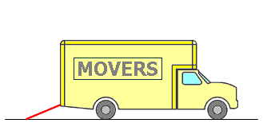

- It reduces the amount of energy needed to carry objects into the truck.
- It reduces the weight of objects being carried into the truck.
- It shortens the distance needed to carry objects into the truck.
- It reduces the size of the force needed to carry objects into the truck.

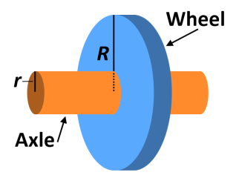
- Look at the diagram of the wheel and axle. The larger the radius of a wheel in comparison to the radius of its axle, the _______________________ the mechanical advantage will be.

- What is mechanical advantage?

- The mechanical advantage of a simple machine:
- reduces the amount of force needed for work.
- creates a force without the input of work.
- allows work to be done without an input force.
- increases the amount of force needed for work.

- Which simple machine can be described as a shaft that is attached to the center of a wheel?
- The toy crane is a compound machine. Which of the following statements about compound machines is true?
- Compound machines consist of two or more simple machines working together.
- Only compound machines can change the size or direction of a force.
- Only compound machines can have a mechanical advantage of 2 or greater.
- Compound machines require no input force in order to do work.

- Rubia was given a type of inclined plane called a ramp in her science class. Her teacher told her that the ramp should have a mechanical advantage of 3. Rubia pulled a block up the ramp, but afterward she calculated that the mechanical advantage of the ramp was 2.8 instead of 3. Her teacher said she did not make a mistake. What did Rubia calculate?

- Which of the following is defined as the ratio of the energy delivered by a system to the energy supplied for its operation?
  - work
  - mechanics
  - efficiency
  - power

- Which of the following pictures shows a person using a compound machine?

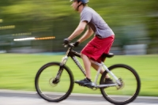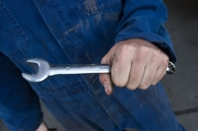

- Which simple machine can be described as a rope that is threaded through a wheel or disk?

- Which of the following is an example of work being done on an object?
  - A box rests on the floor.
  - A man pushes a couch across the room.
  - A prism scatters ultraviolet light into visible light.
  - Water in a pot changes into steam.

- Dean needs to lift the rock shown in the picture below. He wants to use the lever to lift the rock while using the least amount of effort force. At which position should Dean push on the lever?
