Name: _____________________________ Block: _______ Date: ______________________
Inside Balloons: How does air exert pressure?
Directions: Use the simulation “Gas Properties” from phet.colorado.edu to complete the following activity.
Activity:
- Discuss your ideas about “What the word pressure means?” with your partner.
Write down your ideas after discussion.

- Explore the Gas Properties Simulation.

Draw a picture of what you think the air inside this classroom looks like if you could zoom really, really close in on the air.
Use words to help describe what is happening in this picture.
______________________________________________________________________________________________________
- The air inside a balloon will apply pressure on the walls of the balloon.
The air inside the box in the Gas Properties Simulation is applying pressure on the lid.
Suppose you were inside the box in the simulation, pushing up on the lid. How is that similar to, or different than, what the air is doing?
____________________________________________________________________________________________________________________________________________________________________________________________________________________________________________________________________________________________________________________
- Balloons can pop!
How many different ways can you find to blow the top off of the container in the sim? _____
For each method (up to 3), record the reading on the pressure gauge when the top flew off, describe your method and your ideas about how the air is able to blow the top off.
Method  # | Describe your method | Describe what’s changed about the particles are hitting the lid
1
Pressure reading =
2
Pressure reading =
3
Pressure reading =
- Looking at your observations from Question #4, which factors do you think affect air pressure? Justify your answers with evidence from the simulation.
_______________________________________________________________________________________________________________________________________________________________________________________________________________________________________

- Compare the 4 cases and observations about pressure below.
The Comparisons
Starting condition | Hotter  particles | Particles in  smaller box | More,  hotter particles
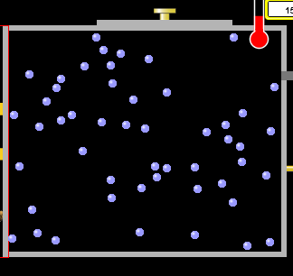 | 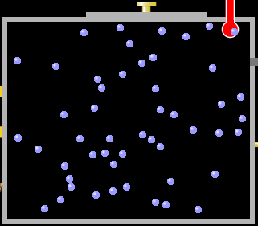 | 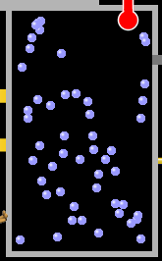 | 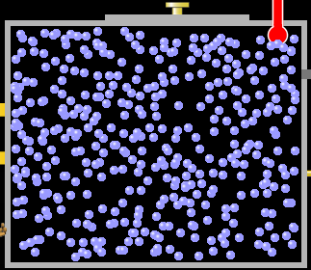
Low  Temperature | High  Temperature | Low  Temperature | High  Temperature
Regular size box | Regular size box | Half size box | Regular size box
The Observations
LOW  PRESSURE | MEDIUM  PRESSURE | MEDIUM  PRESSURE | VERY HIGH PRESSURE
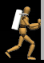 | 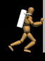
Use the simulation to develop a General Explanation for
how air particles apply pressure
that can explain the differences in the cases above.
Write your general explanation here:

Use your general explanation to explain observations for each case:

