CHRISTOPHER COLUMBUS

FRANCISCO PIZZARO

**HENRY HUDSON**

**HERNANDO CORTÉS**

EXPLORER

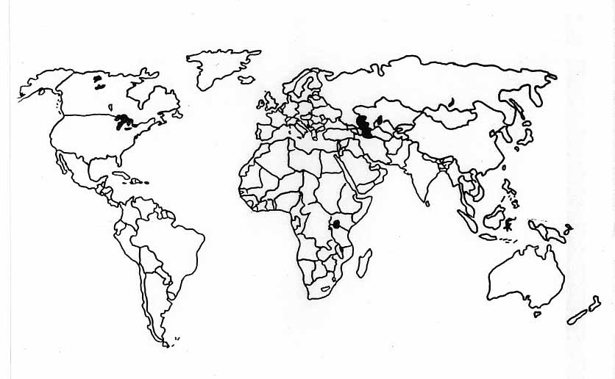

IMPACT

ROUTE OF EXPLORATION

DATES

MOTIVES

SPONSOR

PERSONAL BACKGROUND

