JACQUES CARTIER

FERDINAND MAGELLAN

VASCO DA GAMA

JOHN CABOT

EXPLORER

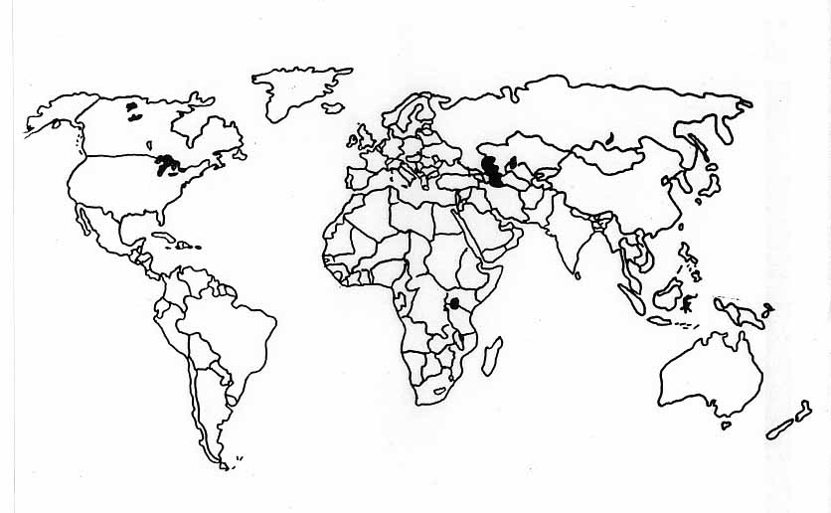

IMPACT

ROUTE OF EXPLORATION

DATES

MOTIVES

SPONSOR

PERSONAL BACKGROUND

