Name: _____________________________ Block: _________ Date: _____________

Energy Test Review

Directions: Complete the following questions.

1. What type of energy transformation occurs when a light bulb is turned on?

2. Into what kinds of energy does a toaster convert electrical energy?

3. Which of the following is an example of kinetic energy being converted to potential energy?
- On a factory assembly line, boxes slide down a ramp.
- The cord of a bow-and-arrow is released, propelling the arrow forward.
- At an ice rink, an ice skater gives another ice skater a gentle push.
- A bike rider stops pedaling and lets his bicycle coast up a hill.

4. Which of the following is a form of energy?
- kinetic
- heat
- potential
- electrical

5. Mechanical energy is the energy due to the __________________ and __________________ of an object.

6. Which of the following statements is true?
- Potential energy is the only type of energy that cannot be transformed into another type of energy.
- Potential energy is the energy that electrons and other charged particles have due to their motion.
- Potential energy is the energy that objects have due to their motion.
- Potential energy is the stored energy that an object has due to its position, shape, or chemical make up.

7. Clyde and Marilyn are riding a roller coaster. During which section(s) of the track is their kinetic energy converted to potential energy?

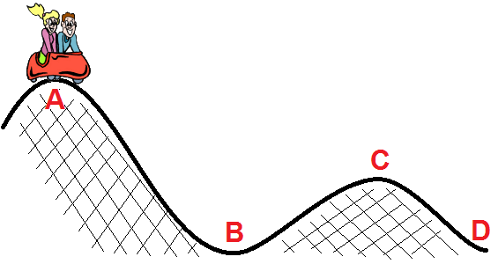

8. The electrical pencil sharpener in Mrs. Brown’s classroom gets very warm on days when many students need to sharpen their pencils. Choose the form of energy to fill in the blank in the energy conversion diagram below.

Electrical Energy _______________________ Heat Energy

9. _____________________ energy is defined as the energy of motion.

10. Which of these is an example of electrical energy that is found in nature?
- the Sun
- a rock on a hillside
- waves crashing
- lightning

11. Kelly is sledding on a snowy hill in the winter. The energy the sled has as it slides down the hill is a form of ____________________ energy

12. A light bulb is turned on. It produces light and warms up. Which statement is true?
- All the electrical energy is transformed to light energy.
- All the electrical energy is transformed to heat energy.
- All the electrical energy is transformed to light energy and heat energy.
- Some of the electrical energy is transformed to light energy and some is destroyed.

13. Study the diagram of the rollercoaster above. Position A is the starting point for the rollercoaster. At which position will the first rollercoaster car have the most kinetic energy?

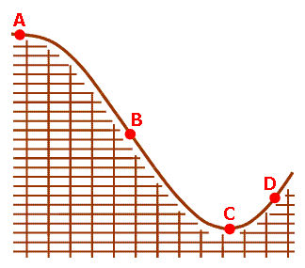

14. A dam is a structure built across a river to hold back the river’s water. The flow of water through a dam is controlled by gates. The water has ______________________ energy what the gates are closed because it cannot flow through the dam. This energy is converted to ___________________ when the gates open and the water begins to move.

15. Jed is skating down a ramp. As his height decreases his ______________________ decreases and his
___________________ increases.

