Name: _________________________________ Block: _________ Date: ____________

Benchmark Test Review

Directions: Complete the following questions.

- Mechanical energy is the energy due to the ________________________ and __________________ of an object.

- The pattern of ____________________ in an area over a long period of time is called ____________.

- The Sun heats the Earth’s water. This warm water turns into a vapor, and rises into the atmosphere, where it cools off. What happens to this water vapor?
  - The water vapor condenses as it cools, then it forms clouds. It later returns to the Earth as precipitation.
  - The water vapor only rises for a very short time, then settles back into the ocean unnoticed.
  - The water vapor pushes clouds out of the way as it rises. This causes overcast conditions to clear.
  - The water vapor evaporates and escapes into space. New water is formed by precipitation.

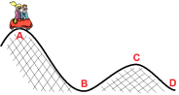
- Clyde and Marilyn are riding a roller coaster. During which section(s) of the track is their potential energy converted to kinetic energy?

- Jenny has two identical marbles. She rolls one marble across a concrete surface with a force of 2N. At the same time, she rolls the other marble across an icy surface with the same force. There is a significantly greater frictional force between the first marble and the concrete surface than between the second marble and the icy surface. This means that…
  - The first marble will roll a longer distance than the second marble.
  - The first marble will slow down and stop before the second marble.
  - The second marble will slow down and stop before the first marble.
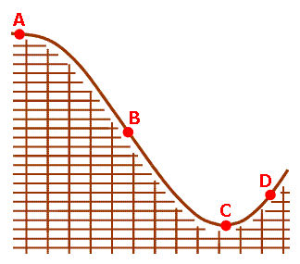
  - The second marble will roll exactly the same distance as the first marble.

- Study the diagram of the rollercoaster. Position A is the starting point for the rollercoaster. At which position will the first rollercoaster car have the most kinetic energy?

- Violently rotating columns of air with winds reaching speeds of nearly 400 mph are called _____________________.

- _______________________________ energy is defined as stored energy.
satellite | length (m) | altitude (km) | mass (kg)
I. | 5.5 | 825 | 692
II. | 9.8 | 825 | 610
III. | 4.4 | 825 | 840
IV. | 5.6 | 825 | 903

- Four weather satellites are orbiting the Earth at a height of 825 km. Some characteristics of the satellites are collected in the table below.
The Earth’s gravity exerts the greatest force on satellite _____________.

- Jed is skating down a ramp. As his height decreases his __________________________ decreases and his ____________________________ increases.

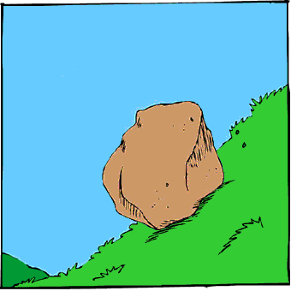
- Look at the rock sitting on the hill in the picture. Gravity should make the rock slide down the hill. What force is acting to balance gravity, keeping the rock in place?

- Choose the list that correctly orders the layers of the atmosphere, beginning with the closest to Earth.
  - Troposphere – Stratosphere – Mesosphere – Thermosphere – Exosphere
  - Exosphere – Mesosphere – Stratosphere – Thermosphere – Troposphere
  - Exosphere – Thermosphere – Mesosphere – Stratosphere – Troposphere
  - Troposphere – Thermosphere – Stratosphere – Mesosphere – Exosphere

- ______________________ measures an object’s change in position per unit time.

- Which of the following is an example of work being done on an object?
a. A prism scatters ultraviolet light into visible light.
b. A man pushes a couch across the room.
c. Water in a pot changes into steam.
d. A box rests on the floor.

- Greenhouse gases are gases that trap heat within the Earth’s atmosphere. What would be the most likely result of an increase in the amount of greenhouse gases in the atmosphere?
  - A reduction in global ocean circulation
  - A decrease in global rainfall
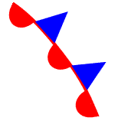
  - A change in global wind patterns
  - An increase in global temperature

- On a weather map, what does the following symbol represent?

- Which of the following is a form of energy?
I. Kinetic II. Heat III. Potential IV. Electrical

- Examine the diagram, which shows stages in the water cycle. Which of the stages of the water cycle is caused when water absorbs heat energy from the Sun?
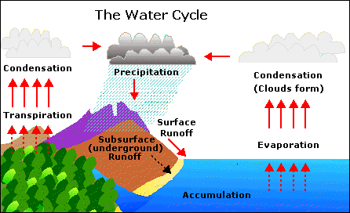

- What type of energy transformation occurs when a light bulb is turned on?
  - Mechanical energy is converted into kinetic energy.
  - Electrical energy is transformed into heat and light.
  - Potential energy is converted into kinetic energy.
  - Electrical energy is transformed into heat and mechanical energy.

- When coal is burned in a power plant for electricity in one city, how might this affect a forest many miles away?
  - It could decrease the amount of carbon dioxide available to the forest.
  - It could contribute to acid rain falling on the forest.
  - It could increase the amount of oxygen available to the forest.
  - It could provide electricity for heating the forest.
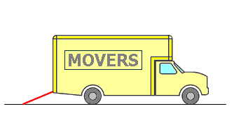
- Which of the following is true about the simple machine shown in red?
  - It reduces the amount of energy needed to carry objects into the truck.
  - It reduces the weight of objects being carried into the truck.
  - It reduces the size of the force needed to carry objects into the truck.
  - It shortens the distance needed to carry objects into the truck.

- What type of front occurs when a cool air mass meets and replaces a warm air mass?

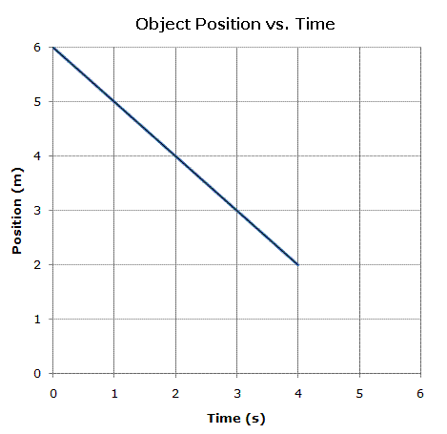
- The graph below shows how the position of an object changes over time. Assuming that the motion of the object remains the same, at what position will the object be when it has traveled for a total of 6s?

- The crane is a compound machine. Which of the following statements about compound machines is true?
  - Only compound machines can have a mechanical advantage of 2 or greater.
  - Compound machines require no input force in order to do work.
  - Only compound machines can change the size or direction of a force.
  - Compound machines consist of two or more simple machines working together.

- A swirling, high-speed windstorm begins over the ocean. It contains heavy rains. The wind and rain rotate around a center of low pressure. When the winds inside this tropical cyclone reach 74 mph, what occurs?

- The force of gravity between two objects is affected by:
- The masses of the objects
- The volumes of the objects
- The densities of the objects
- The distance between the objects.

- If the forces acting on an object are balanced, the object is
  - Speeding up or slowing down
  - Speeding up or in constant motion
  - At rest of in constant motion
  - At rest of speeding up

- Which of the following pictures shows a person using a compound machine?
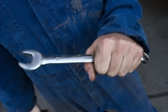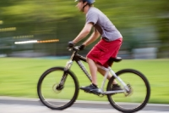
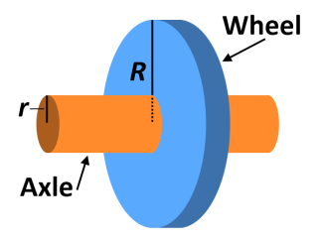
- Look at the diagram of the wheel and axle. The larger the radius of a wheel in comparison to the radius or its axle, the _______________________ the mechanical advantage will be.

- Adam uses a fixed pulley to lift an object. Adam applies an input force to the pulley as he pulls down to lift the object. As he does this, Adam wonders about how the pulley is helping him. Hos is the pulley helping Adam lift the object?
a. A fixed pulley increases the distance over which the force is applied.
b. All of these answers are correct.
c. A fixed pulley helps Adam change the direction of the effort force.
d. A fixed pulley lowers the amount of force needed to do the same amount of work.

- Rubia was given a type of inclined plane called a ramp in her science class. Her teacher told her that the ramp should have a mechanical advantage of 3. Rubia pulled a block up the ramp, but afterward she calculate that the mechanical advantage of the ramp was 2.8 instead of 3. Her teacher said she did not made a mistake. What did Rubia calculate?

- Newton’s first law of motion states that an object will keep a constant speed and direction unless acted upon by an unbalanced force. To test this statement, Martin rolled a ball on a long, level street. The ball did not bump into any object, but it eventually came to a stop. How is this possible?

- What is mechanical advantage?
  - A property of some machines that allows them to do work with no input force.
  - A measure of how much a machine multiplies the force applied to it
  - A characteristic that compound machines have and simple machines lack.
  - A theory stating that machines are better at performing tasks than humans.

- Last-minute Louis frantically tried to finish his homework while his mom drove him to school. He placed his book on his lap and was reaching for a pencil when his mom suddenly slammed on the brakes. Although Louis stayed buckled in his seat, his book flew forward and crashed into the front windshield. What was most responsible for the book flying forward?

- A ball is dropped from a tower, from whose reference point is the ball approaching the observer?
  - A person in an airplane flying above the tower.
  - A person standing on the ground beneath the tower.
  - A person on the ground driving rapidly away from the tower.
  - A person standing on top of the tower.

