Amoeba Information
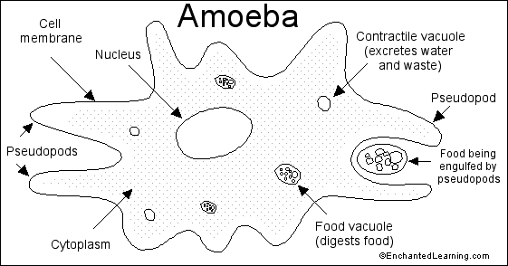
The amoeba is a tiny, one-celled organism. You need a microscope to see most amoebas - the largest are only about 1 mm across. Amoebas live in fresh water (like puddles and ponds), in salt water, in wet soil, and in animals (including people). There are many different types of amoebas. The name amoeba comes from the Greek word amoibe, which means change. (Amoeba is sometimes spelled ameba.)
Anatomy: An amoeba consists of a single blobby cell surrounded by a porous cell membrane. The amoeba "breathes" using this membrane - oxygen gas from the water passes in to the amoeba through the cell membrane and carbon dioxide gas leaves through it. A complex, jelly-like series of folded membranes called cytoplasm fills most of the cell. A large, disk-shaped nucleus within the amoeba controls the growth and reproduction of the amoeba.
food vacuole - a cavity within the amoeba in which food is digested (broken down in order to be absorbed by the amoeba).
food being engulfed by pseudopods - the amoeba "eats" by surrounding bits of food with pseudopods that form around the food; the amoeba then incorporates the food into the cell, forming a food vacuole.
nucleus - the major organelle of the amoeba, located centrally; it controls reproduction (it contains the chromosomes) and many other important functions (including eating and growth).
pseudopods - temporary "feet" that the amoeba uses to move around and to engulf food.
Diet: Amoebas eat algae, bacteria, plant cells, and microscopic protozoa and metazoa - some amoebas are parasites. Amoebas eat by surrounding tiny particles of food with pseudopods, forming a bubble-like food vacuole. The food vacuole digests the food. Wastes and excess water are transported outside the cell by contractile vacuoles.
Locomotion: Amoebas move by changing the shape of their body, forming pseudopods (temporary foot-like structures). The word pseudopod means "false foot."
Reproduction: Amoebas reproduce asexually by binary fission. A parent cell divides (the nucleus also divides in a process called fission) and produces two smaller copies of itself.

